Constructor Injection vs Setter vs Field Injection

What is Dependency Injection ?
Dependency Injection (DI) means:
In Spring Boot, objects do not build their dependencies — the framework (Creates and Supplies) injects them automatically at runtime.
Without DI:
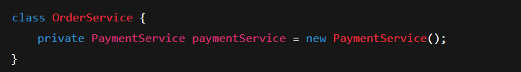This is tight coupling.
With DI:
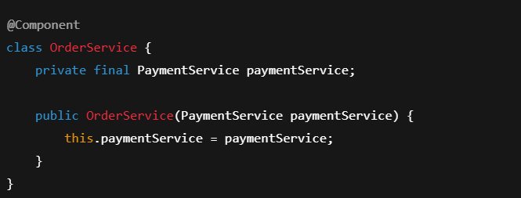Now Spring controls object creation.
Dependency Injection (DI) in Spring Boot is a design principle where the Spring container creates, manages, and supplies required objects (dependencies) to a class, instead of the class creating them itself.

This allows:
- Loose coupling
- Easier testing
- Better maintainability
- Scalable enterprise design
Dependency Inversion Principle (SOLID)
DIP says:
High-level modules should not depend on low-level modules.
Both should depend on abstractions.
Bad:
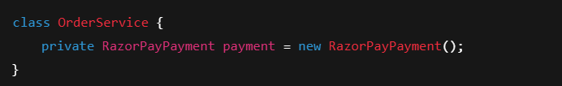Good:
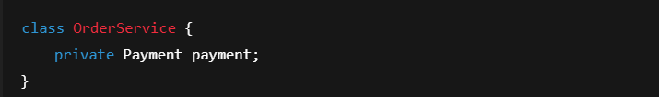Spring injects the implementation.

Types of Dependency Injection
Spring supports:
- Field Injection
- Setter Injection
- Constructor Injection

Field Injection (First – Worst)
Code
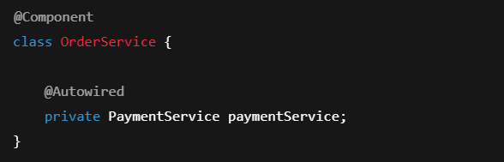
How it works internally
- Spring creates object using default constructor
- Uses reflection
- Injects field later
Problems
Issue | Why
NPE risk | Object can be used before injection
Not immutable | Cannot mark field final
Hidden dependencies | Not visible in constructor
Hard to test | Must use Spring context
Breaks encapsulation | Reflection bypass

Setter Injection
Code
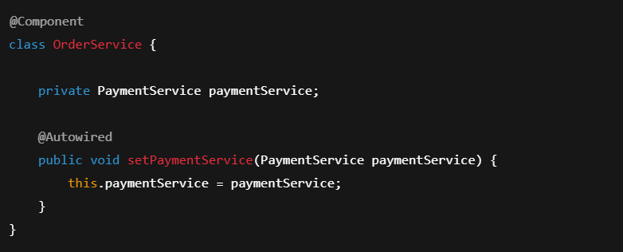
How it works
- Object created
- Setter called
- Dependency injected later

Advantages
Benefit | Reason
Optional dependencies | Can skip setter
Easy mocking | Can replace dependency
Flexible | Can change dependency

Disadvantages
Issue | Why
Not immutable | Cannot mark final
Object incomplete | Dependency set later
Harder to read | Dependencies hidden

Constructor Injection (Enterprise Standard)
Code
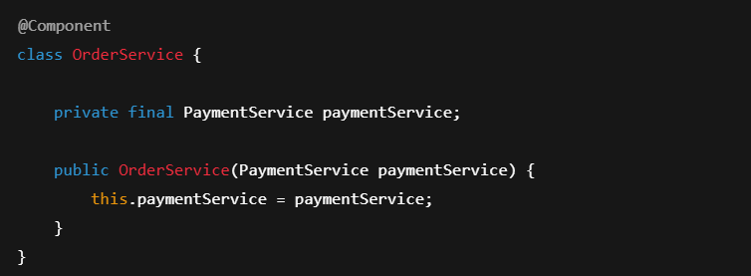
Key Rules
Rule | Explanation
@Autowired optional | If only one constructor
Multiple dependencies | Allowed
Fields can be final | Immutability
Injected at creation | Object never incomplete
Why Constructor Injection is Preferred ?
Feature | Constructor Injection | Setter Injection | Field Injection
Immutability | ✅ | ❌ | ❌
Fail fast | ✅ | ❌ | ❌
Testability | ✅ | ⚠️ | ❌
Clear design | ✅ | ⚠️ | ❌
Thread-safe | ✅ | ❌ | ❌
Constructor Injection enforces correct object creation.

Fail Fast Behavior
Missing dependency:
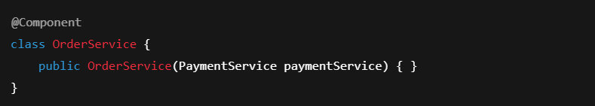 If bean missing → Application fails at startup This is good
But Field Injection fails at runtime with NPE This is bad

Circular Dependency Behaviour
Field Injection allows cycle:
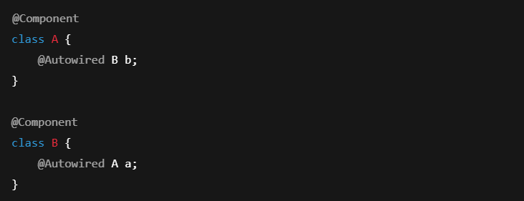
Spring can break using proxies.
Constructor Injection:
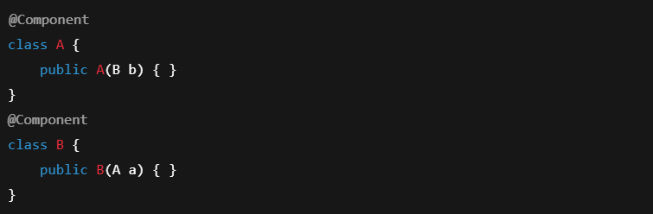 Fails immediately → Correct design enforcement

Unsatisfied Dependency
Unsatisfied Dependency occurs when Spring cannot find or create a bean that another bean depends on.

Spring knows what you need, but it cannot find what to inject So application startup fails.
Because Spring does Dependency Injection at startup.
If even one dependency is missing → Spring stops the application.

Example
Step 1: Service depends on Repository
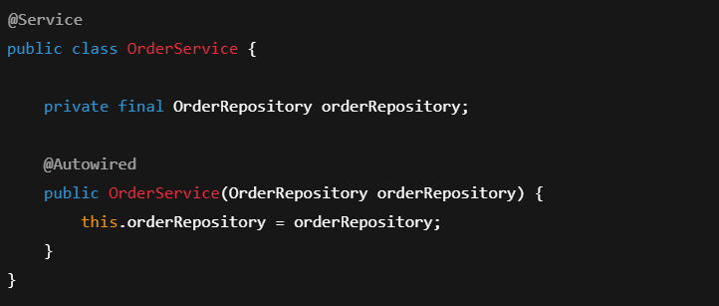Spring must find a bean of type OrderRepository.
Step 2: Repository is NOT a Spring Bean
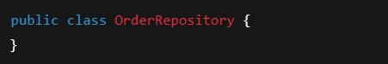
Now when Spring starts:


Step 3: Application crashes
Typical error:
Unsatisfied dependency expressed through constructor parameter 0;
No qualifying bean of type 'OrderRepository' available
Meaning:
I tried to inject OrderRepository, but no such bean exists.

Correct Version
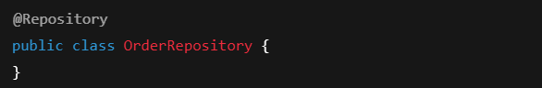Now Spring registers it as a bean.
Startup succeeds.

Multiple Beans Problem
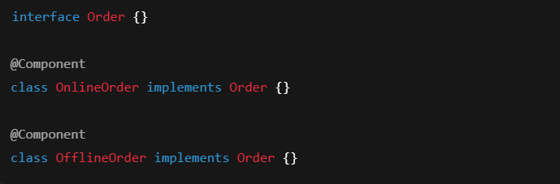Injection:
❌ Error: 2 beans found.

Solution for Multiple beans problem
@Primary
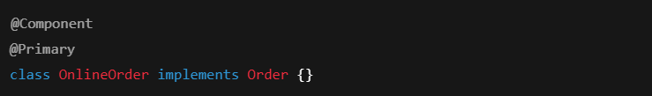Now Spring picks OnlineOrder by default.

@Qualifier
Explicit selection.

@Primary vs @Qualifier Precedence
Used Together | Winner
Both present | @Qualifier
Using @Primary and @Qualifier in All Injections
Field
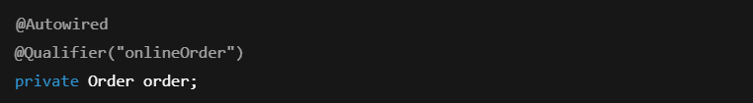Setter
Constructor
Summary of Multiple Implementations Problem
If interface has 2 implementations → Spring confused.
Solution:
- Use @Primary for default
- Use @Qualifier for explicit control

Hidden Traps
Trap | Explanation
Field injection passes interviews | Fails in real systems
Circular deps hidden | Field injection masks design flaws
Proxy confusion | Lazy beans hide cycles
Unit testing pain | Field injection blocks mocking

One-Page Mental Model
Field → Convenient but dangerous
Setter → Flexible but incomplete objects
Constructor → Safe, strict, production-grade

Top Interview Questions
- Why is constructor injection preferred?
→ Immutability + fail-fast + testability
- When is @Autowired optional?
→ Single constructor
- Can we autowire two constructors?
→ No
- Which injection best for mandatory deps?
→ Constructor
- Why field injection is bad?
→ Hidden deps, no immutability
- How to resolve multiple beans?
→ @Primary / @Qualifier
- Which has higher priority?
→ @Qualifier
- Does constructor injection allow circular deps?
→ No (by design)
- Why is that good?
→ Enforces better architecture
- Which injection best for unit testing?
→ Constructor
Must-Know Dependency Injection Annotations in Spring Boot
@Autowired – Injects dependency automatically
@Qualifier – Chooses one bean when multiple exist
@Primary – Sets default bean
@Component – Makes a class a Spring bean
@Service – Business layer bean
@Repository – DAO layer bean
@Configuration – Configuration class
@Bean – Manually creates a bean
@Inject – Java standard alternative to @Autowired
@Resource – Injects by name first, then type

Final Summary — As a Story
Spring Initializr creates project.
pom.xml defines dependencies.
Spring Boot auto-configures beans.
When ApplicationContext starts:
Spring creates each bean.
With Field Injection → object created first, fixed later
With Setter Injection → object created, modified later
With Constructor Injection → object created correctly once
Enterprise systems demand correct objects from birth — not patched later.
That is why Constructor Injection dominates real systems.

